DATA FLOW DIAGRAMS (DFD)
Name: Amey Barbade, Roll no. 2403012
Experiment No. 3

1. Introduction
Data Flow Diagrams (DFDs) are graphical models used in software engineering to represent how data enters a system, how it is processed, where it is stored, and how outputs are delivered to external entities. DFDs focus on the logical flow of data rather than implementation details such as program code or user interface.

For the ChargeSure AI-Powered EV Charging Management Platform, the DFD hierarchy models the flow of information between Drivers/EV Owners, Station Operators, System Administrators, and External APIs, along with the internal system processes and data stores. The terminology and functional decomposition used here are derived from the Software Requirements Specification (SRS) of the system.

2. What is a Data Flow Diagram?
A Data Flow Diagram (DFD) is a graphical representation of how data moves through an information system. It illustrates how data is processed, stored, and transferred between different components. DFDs are organized into multiple levels, starting from a high-level overview (Level 0) and progressing to detailed representations (Level 1 and Level 2), enabling a clear understanding of system functionality.

3. Objectives of DFD
- Identify the sources and destinations of data in the system.
- Show how input data is transformed into meaningful output.
- Represent major processes and system boundaries.
- Identify data storage requirements.
- Improve communication among developers, analysts, and stakeholders.
- Support system design and requirement analysis.

4. Standard DFD Notations
- Rectangle: External Entity (e.g., Driver / EV Owner, Station Operator, System Administrator, External APIs)
- Circle: Process (e.g., Register & Auth, Manage Bookings, Triage Complaints)
- Open-ended Rectangle: Data Store (e.g., D1 User DB, D2 Station DB, D3 Booking DB)
- Arrow: Data Flow (e.g., Booking Request, Predicted Availability, Station Updates)

5. Important DFD Rules
- Every data flow must be clearly labeled.
- Processes must transform input data into output data.
- Data stores are used for persistent storage.
- External entities should not directly interact with data stores.
- Each process must have valid inputs and outputs.
- Level 2 diagrams must be a detailed decomposition of Level 1 processes.
- Lower-level DFDs must maintain consistency with higher-level diagrams.

6. DFD Levels Used for the ChargeSure Platform

6.1 Level 0 - Context Diagram
The entire system is represented as a single process: 0.0 ChargeSure Platform.
This level shows interactions between the system and its external entities:
- Driver / EV Owner: Provides Login/Vehicle Info, Bookings, and Complaints. Receives Predicted Availability, SoH, and Route Plans.
- Station Operator: Provides Station Metadata Updates. Receives Usage Analytics and Ghost-Station Alerts.
- System Administrator: Provides Moderation and Station Verifications. Receives Platform-wide Reports.
- External APIs (Google, Maps, Payments): Exchange Auth Tokens, Map Data, and Payment Confirmations.
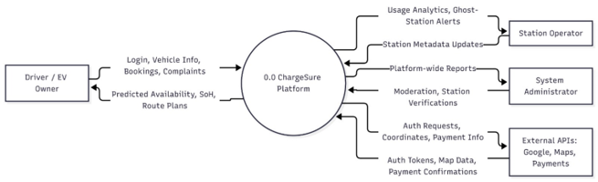

6.2 Level 1 Diagram
Level 1 breaks the system into its major functional modules:
- 1.0 Register & Auth
- 2.0 Aggregate Stations
- 3.0 Manage Bookings
- 4.0 Estimate Health
- 5.0 Triage Complaints
Each module represents a key functionality of the system and shows interactions with data stores (User DB, Station DB, Booking DB, History DB, Complaint DB) and external entities.
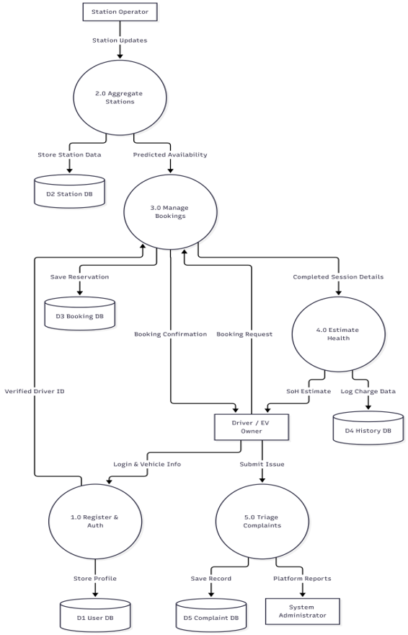

6.3 Level 2 Diagrams
Level 2 provides detailed decomposition of selected Level 1 processes. The following two Level 2 DFDs are included:
Level 2 DFD 1: 3.0 Manage Bookings Process
This diagram decomposes the booking module into specific subprocesses:
- 3.1 Validate Request
- 3.2 Check Station Capacity
- 3.3 Process Payment (interacting with External Payment APIs)
- 3.4 Confirm Reservation
Data is validated against the User DB and Station DB, and the finalized reservation is saved in the Booking DB.
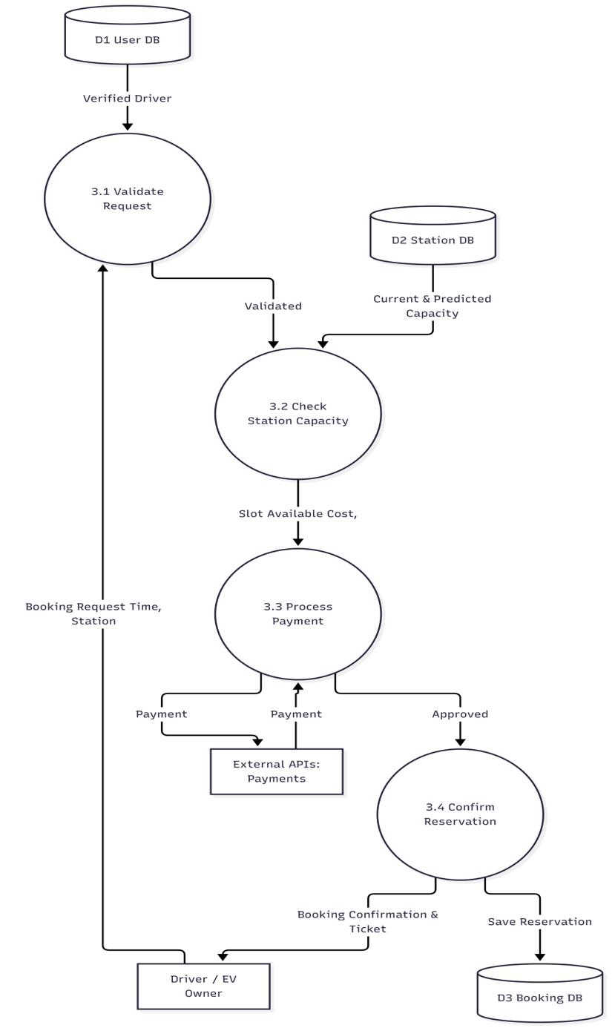
Level 2 DFD 2: 5.0 Triage Complaints & Alerts
This diagram details the complaint resolution and anomaly detection workflows:
- 5.1 Receive Complaint
- 5.2 Execute NLP Triage
- 5.3 Detect Ghost Stations (checking check-ins & sessions against Station DB)
- 5.4 Manage Alerts & Reports
Output includes high-urgency alerts routed to Station Operators and platform-wide moderation reports to System Administrators.
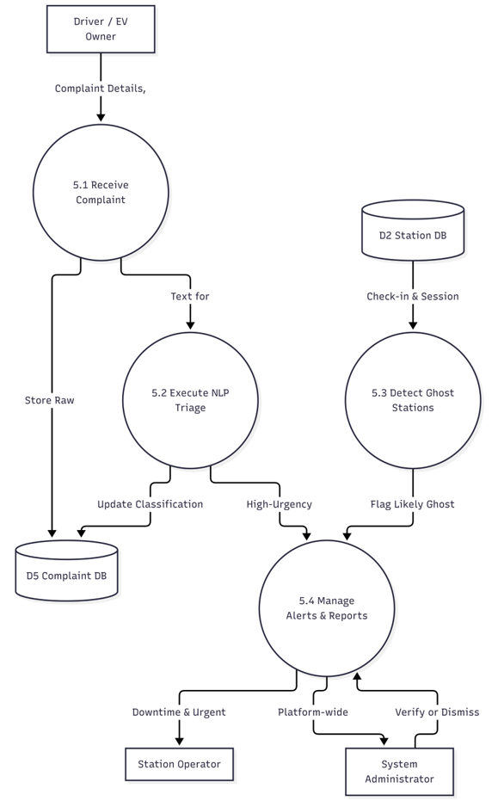

7. Major Data Flows in ChargeSure
- Booking Request Flow: Driver -> 3.1 Validate Request -> 3.2 Check Capacity -> 3.3 Process Payment -> 3.4 Confirm Reservation -> D3 Booking DB.
- Complaint Triage Flow: Driver -> 5.1 Receive Complaint -> 5.2 Execute NLP Triage -> D5 Complaint DB & High-Urgency Alerts.
- Ghost Station Detection Flow: D2 Station DB -> 5.3 Detect Ghost Stations -> Flag Likely Ghost -> 5.4 Manage Alerts -> System Admin/Station Operator.

8. Advantages of DFDs
- Provides a simple and clear visualization of data flow within the ChargeSure system.
- Helps understand how driver data, station details, and payments move through the system.
- Improves communication between developers and stakeholders.
- Helps identify critical processes such as NLP triage, capacity checking, and payment processing.
- Acts as a foundation for designing databases (User DB, Station DB, Booking DB, History DB, Complaint DB).

9. Limitations of DFDs
- DFDs do not describe internal algorithms such as the NLP text classification or battery State of Health (SoH) math.
- They do not represent user interface details like dashboards or map layouts.
- Timing aspects such as real-time socket connections for booking locks are not shown.

Conclusion
The Data Flow Diagram (DFD) hierarchy provides a structured and logical representation of the ChargeSure EV Charging Management Platform. The Level 0 context diagram defines the system boundary and interactions with external entities like Drivers, Operators, Admins, and External APIs. The Level 1 diagram decomposes the system into major functional modules. The Level 2 diagrams further break down key modules such as Manage Bookings and Triage Complaints into detailed subprocesses. Together, these diagrams provide a comprehensive view of how the system processes data for EV charging.

